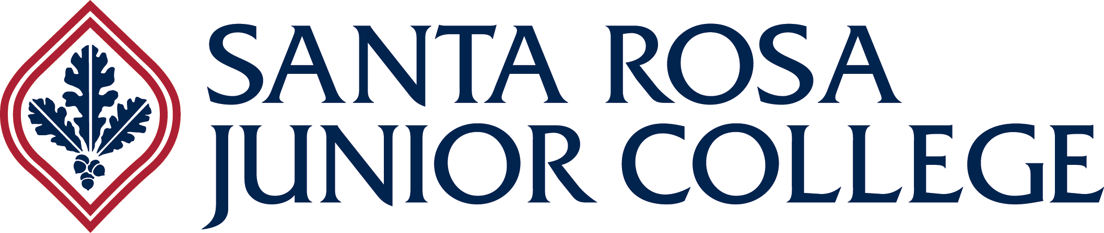 Department of Health Sciences

To: Dental Hygiene Class
From: Professor Fleckner, 1st Year Coordinator DHI
Date: 4/1/19
Re: Equipment for Dental Hygiene Program

Hi Dental Hygiene Students

Congratulations on beginning your education toward a career in Dental Hygiene.
I look forward to working with all of you over the next two years. This memo is to get you started in the preparation for your first year of your dental hygiene education.

You will be expected to purchase equipment, instruments and supplies for your home practice and experiences in the dental hygiene clinic. All students will be required to purchase all equipment, instruments and supplies. You may not omit materials even if you already have access to these items. All students must purchase these items. We have been able to get highly reduced school pricing for all of your required items, the kits will be obtained through the school providers. There are no exceptions. Further information on kits, uniforms and supplies will be available during the Dental Programs Orientation on Wednesday, June 19th, 2019.

Before the June 19th orientation (Please order by June 17th):
The following items must be ordered through direct contact with the provider.
(Kilgore Typodont, bench mount, 10 typodont teeth) These items must be ordered before the orientation in order to receive them before the beginning of the semester. I have contacted Kilgore with a list of all accepted students. I will be contacting Kilgore again on June 17th to make sure all students have contacted the company with their order

The Kilgore company will be shipping the entire order to the school for you to pick up with the rest of your equipment on Monday, August 19th.

Please visit their webpage set up specifically for Santa Rosa Students:
www.kilgoreinternational.com - click sign in on the top bar - do not click on create an account
1) Log into 'www.kilgoreinternational.com'

2) In the upper right hand corner next to 'Welcome', place your cursor over 'Products' until the drop down appears. Then, click onto 'School Course Links'

3) The Password Page will appear. Type 'Schools2019' (with a capital S) and click enter

4) A list of Schools and Institutions will appear. Click onto “Santa Rosa Junior College” to review your kit.

5) Add the kit to cart and use your credit card information to purchase

Please note: No matter which address you put into the shipping fields, the product will be sent to the school.

The total cost is $438.97 this includes the typodont and bench mount, tax and shipping to Santa Rosa Junior College.

Please do this by Monday, June 17th so that I am able to assure your order before the orientation on June 19th. I will be checking with the Kilgore representative on that Monday to determine if any student’s names are missing from their list.

I look forward to meeting all of you at orientation and working with you over the next two years.

Regards,

Professor Fleckner, RDH, MS.
1st Year Clinical Coordinator, Dental Hygiene
1501 Mendocino Ave.
Santa Rosa, CA. 95401
lfleckner@santarosa.edu

707-527-4934

